**Technology Architecture**

|  |  |
| --- | --- |
| Date | 26-10-2022 |
| Team ID | PNT2022TMID06420 |
| Project Name | Project: IoT Based Safety Gadget for Child Safety Monitoring & Notification |
| Maximum Marks | 4 Marks |

**Technical Architecture:**

|  |  |  |  |
| --- | --- | --- | --- |
| **S.No** | **Component** | **Description** | **Technology** |
| 1. | User Interface | The communication protocol being used in the proposed solution might act as an interface the way like Wi-Fi, Bluetooth and ZigBee | MIT app |

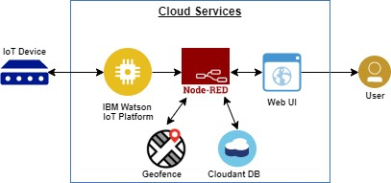

**Components & Technologies:**

|  |  |  |  |
| --- | --- | --- | --- |
| 2. | Application Logic | The data to be collected and sent to the  authenticator’s(parent) via GSM providing the GPS coordinates to easily locate access and monitor the child | IBM Watson STT service, python etc |
| 3. | Database | Data to be segregated and secured in the form of relational DBMS | MySQL |
| 4. | Cloud Database | IBM | IBM Cloudant |
| 5. | File Storage | File storage requirements | IBM Block Storage or Other Storage Service or Local Filesystem |
| 6. | External API-1 | To access the children location | GPS location monitoring etc |
| 7. | Infrastructure (Server / Cloud) | Application Deployment on Local System / Cloud Local Server Configuration | Cloud Foundry |